### Q1:

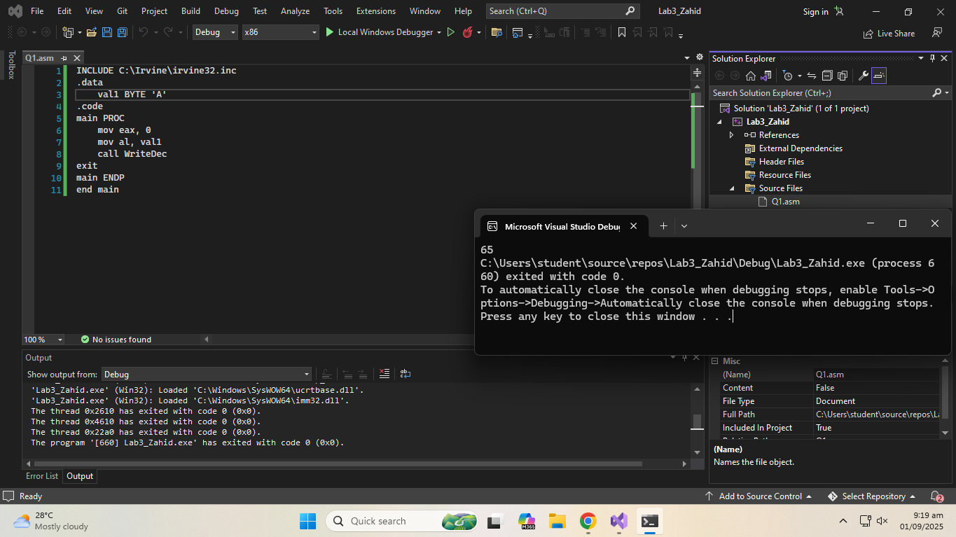

**Code:**

INCLUDE C:\Irvine\irvine32.inc

.data

val1 BYTE 'A'

.code

main PROC

mov eax, 0

mov al, val1

call WriteDec

exit

main ENDP

end main

**Q2:**

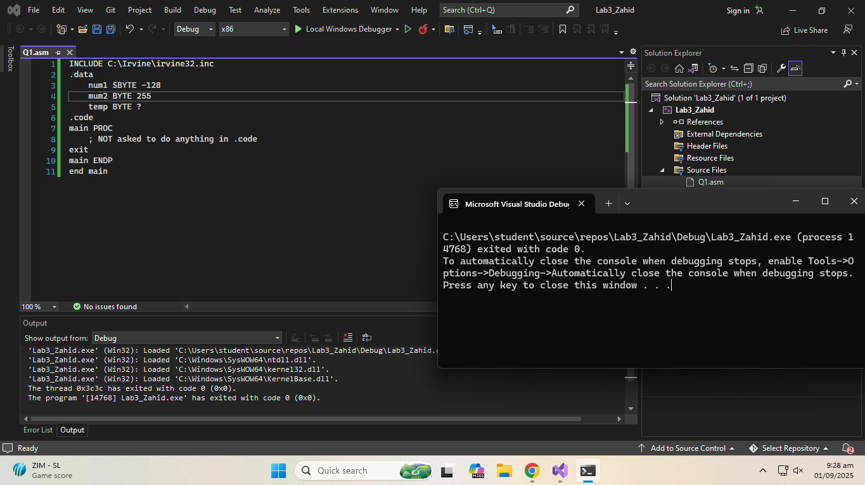

**Code:**

INCLUDE C:\Irvine\irvine32.inc

.data

num1 SBYTE -128

mum2 BYTE 255

temp BYTE ?

.code

main PROC

; NOT asked to do anything in .code

exit

main ENDP

end main

**Q3:**

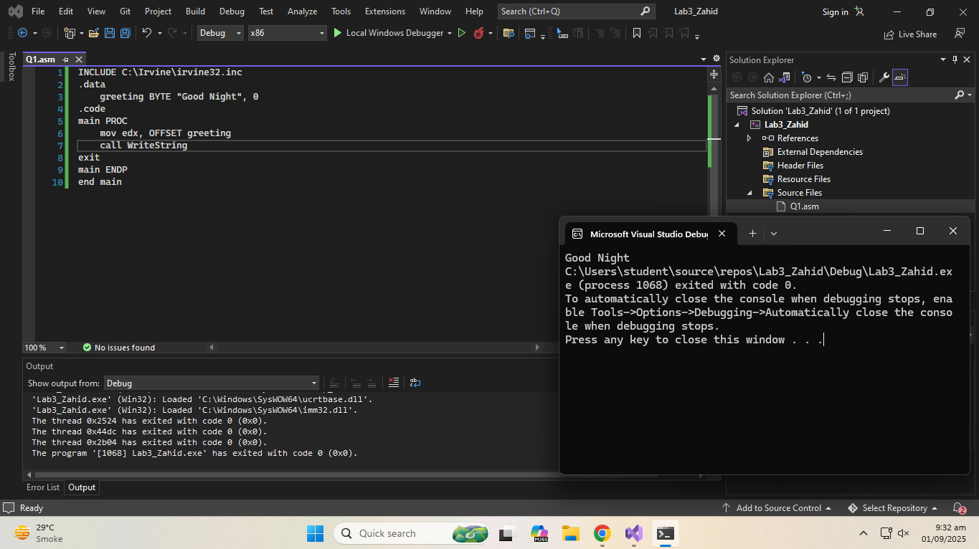

**Code:**

INCLUDE C:\Irvine\irvine32.inc

.data

greeting BYTE "Good Night", 0

.code

main PROC

mov edx, OFFSET greeting

call WriteString

exit

main ENDP

end main

**Q4:**

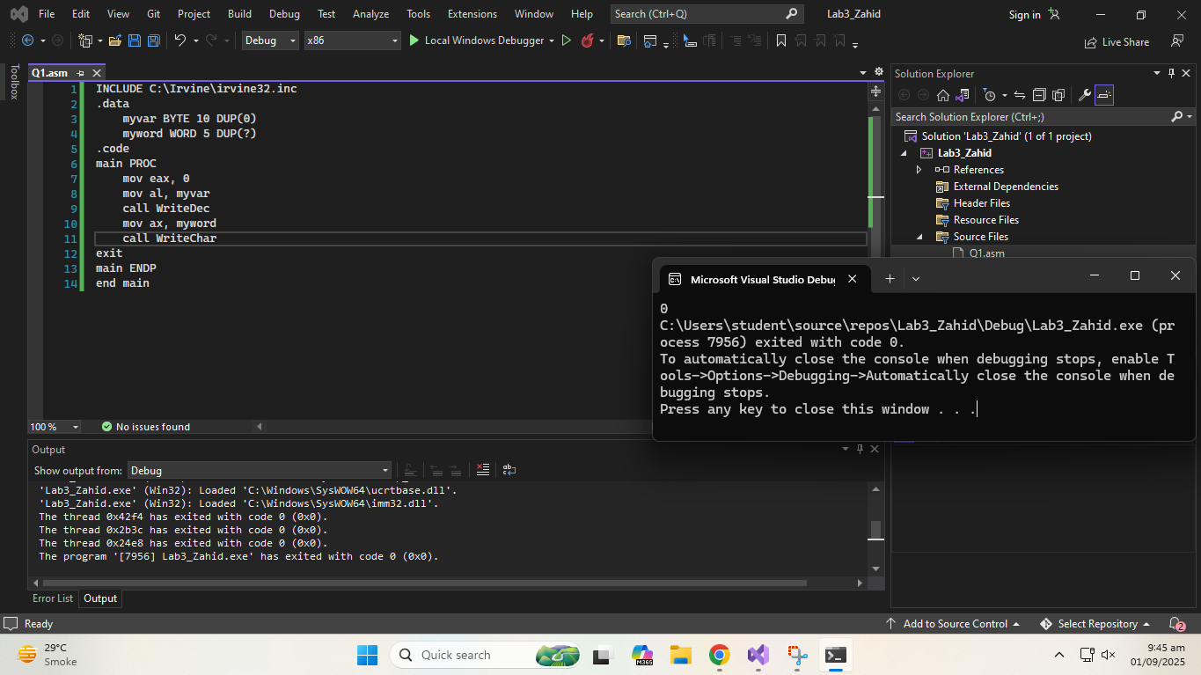

**Code:**

INCLUDE C:\Irvine\irvine32.inc

.data

myvar BYTE 10 DUP(0)

myword WORD 5 DUP(?)

.code

main PROC

mov eax, 0

mov al, myvar

call WriteDec

mov ax, myword

call WriteChar

exit

main ENDP

end main

**Q5:**

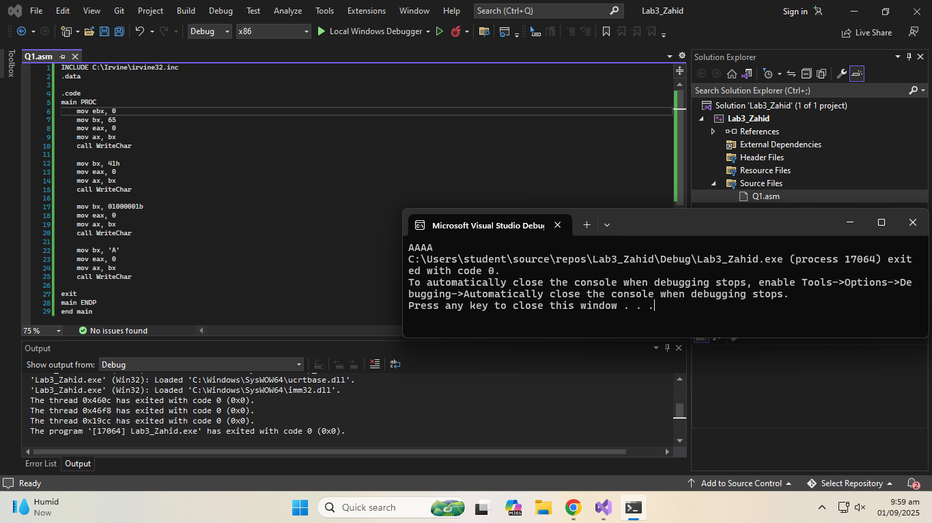

**Code:**

INCLUDE C:\Irvine\irvine32.inc

.data

.code

main PROC

mov ebx, 0

mov bx, 65

mov eax, 0

mov ax, bx

call WriteChar

mov bx, 41h

mov eax, 0

mov ax, bx

call WriteChar

mov bx, 01000001b

mov eax, 0

mov ax, bx

call WriteChar

mov bx, 'A'

mov eax, 0

mov ax, bx

call WriteChar

exit

main ENDP

end main

**Q6:**

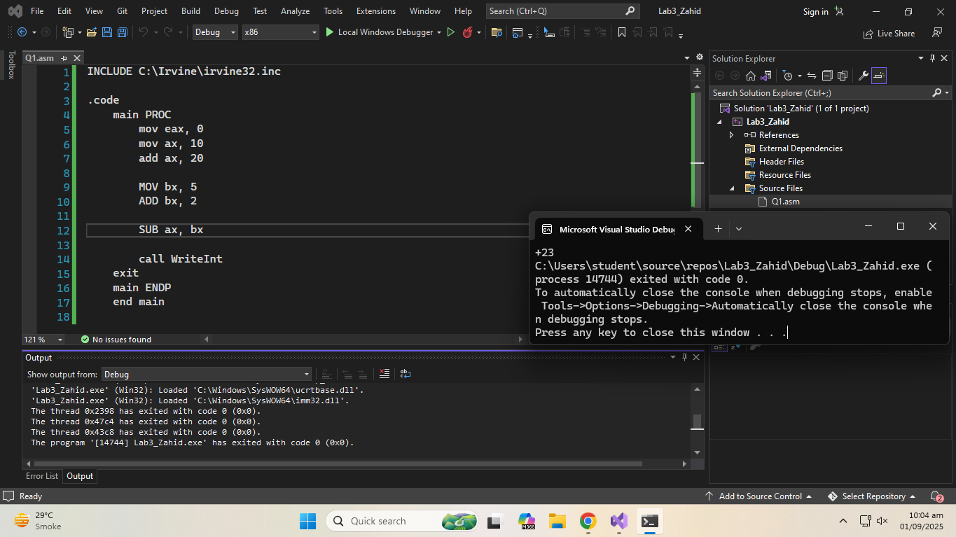

**Code:**

INCLUDE C:\Irvine\irvine32.inc

.code

main PROC

mov eax, 0

mov ax, 10

add ax, 20

MOV bx, 5

ADD bx, 2

SUB ax, bx

call WriteInt

exit

main ENDP

end main

**Q7:**

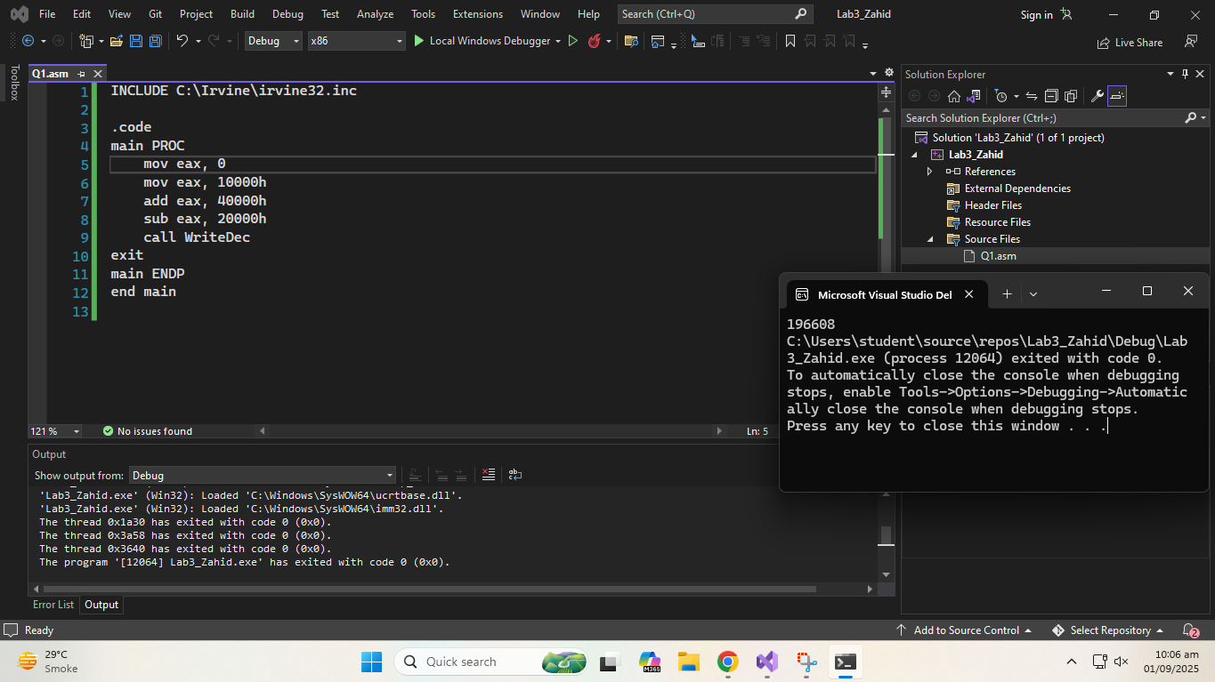

**Code:**

INCLUDE C:\Irvine\irvine32.inc

.code

main PROC

mov eax, 0

mov eax, 10000h

add eax, 40000h

sub eax, 20000h

call WriteDec

exit

main ENDP

end main